**Bangladesh Rainfall Prediction**

Data set -> https://www.kaggle.com/redikod/historical-rainfall-data-in-bangladesh

| **Index** | **StationIndex** | **Station** | **Year** | **Month** | **Day** | **Rainfall** |
| --- | --- | --- | --- | --- | --- | --- |
| **0** | 1 | Dhaka | 1970 | 1 | 1 | 0 |
| **1** | 1 | Dhaka | 1970 | 1 | 2 | 0 |
| **2** | 1 | Dhaka | 1970 | 1 | 3 | 0 |
| **3** | 1 | Dhaka | 1970 | 1 | 4 | 0 |
| **4** | 1 | Dhaka | 1970 | 1 | 5 | 0 |
| **5** | 1 | Dhaka | 1970 | 1 | 6 | 0 |
| **6** | 1 | Dhaka | 1970 | 1 | 7 | 0 |
| **7** | 1 | Dhaka | 1970 | 1 | 8 | 0 |
| **8** | 1 | Dhaka | 1970 | 1 | 9 | 0 |
| **9** | 1 | Dhaka | 1970 | 1 | 10 | 0 |
| **10** | 1 | Dhaka | 1970 | 1 | 11 | 0 |
| **11** | 1 | Dhaka | 1970 | 1 | 12 | 0 |
| **12** | 1 | Dhaka | 1970 | 1 | 13 | 1 |
| **13** | 1 | Dhaka | 1970 | 1 | 14 | 0 |
| **14** | 1 | Dhaka | 1970 | 1 | 15 | 0 |
| **15** | 1 | Dhaka | 1970 | 1 | 16 | 0 |
| **16** | 1 | Dhaka | 1970 | 1 | 17 | 0 |
| **17** | 1 | Dhaka | 1970 | 1 | 18 | 0 |
| **18** | 1 | Dhaka | 1970 | 1 | 19 | 0 |
| **19** | 1 | Dhaka | 1970 | 1 | 20 | 0 |

Size of data set-> 32,54,256 ROWS and 6 COLUMNS

Training Models on 5 years of Rainfall data (from 1970 to 1975)

Plot of Rainfall each month of the year being predicted(1976) (Actual values)

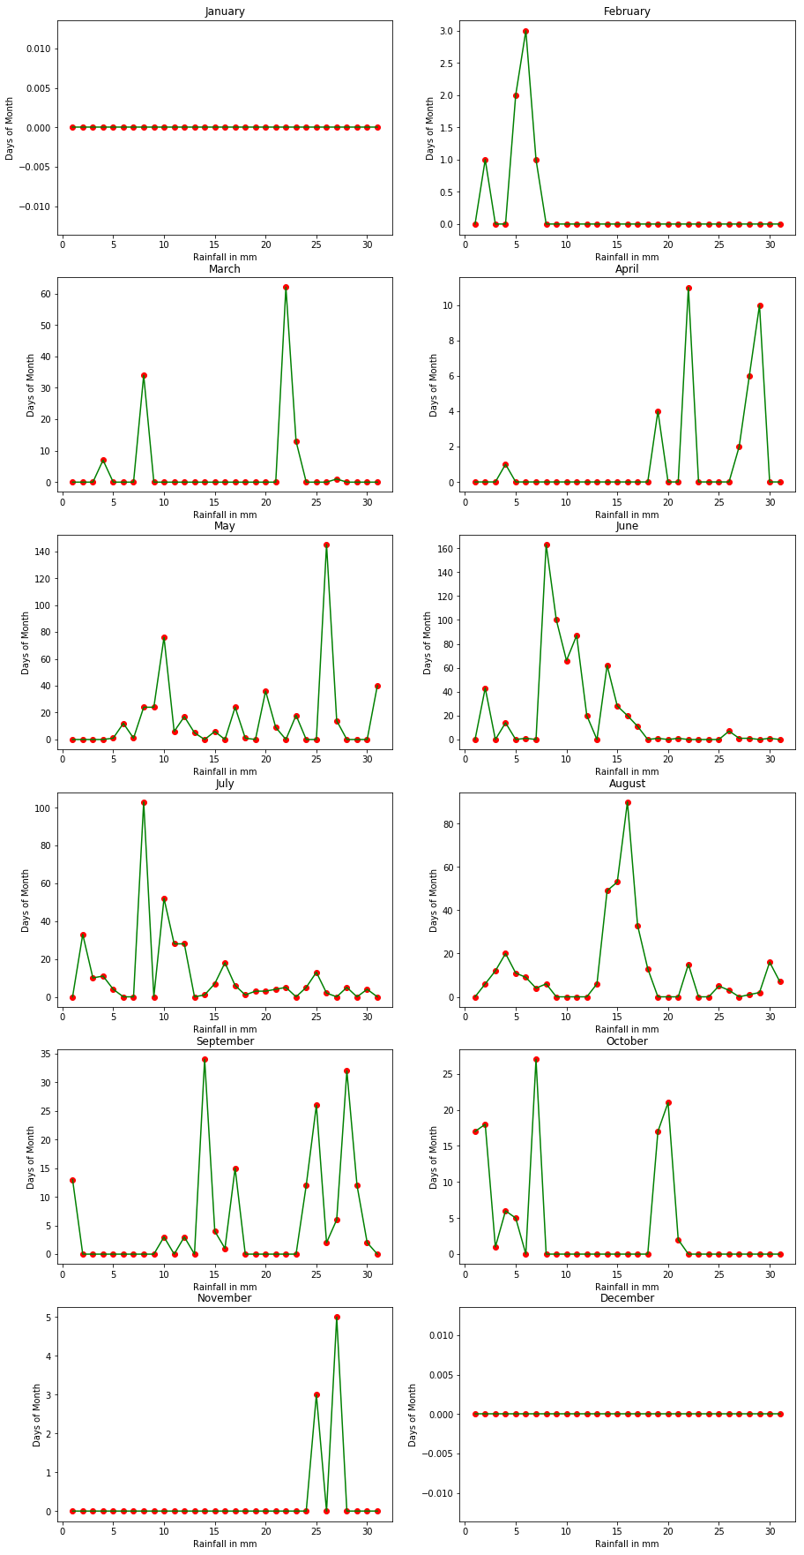

**Using SVM**

Predicted values

| **Index** | **Actual Rainfall** | **Predicted Rainfall** |
| --- | --- | --- |
| **1892** | 1 | 1 |
| **1895** | 2 | 2 |
| **1896** | 3 | 3 |
| **1897** | 1 | 1 |
| **1925** | 7 | 7 |
| **1929** | 34 | 34 |
| **1943** | 62 | 60 |
| **1944** | 13 | 13 |
| **1948** | 1 | 1 |
| **1956** | 1 | 1 |
| **1971** | 4 | 4 |
| **1974** | 11 | 11 |
| **1979** | 2 | 2 |
| **1980** | 6 | 6 |
| **1981** | 10 | 10 |
| **1988** | 1 | 1 |
| **1989** | 12 | 12 |
| **1990** | 1 | 1 |
| **1991** | 24 | 24 |
| **1992** | 24 | 24 |
| **1993** | 76 | 75 |
| **1994** | 6 | 6 |
| **1995** | 17 | 17 |
| **1996** | 5 | 5 |
| **1998** | 6 | 6 |

**Graph(SVM)**

Blue lines are predicted values, Green lines along with Red dots is the Actual value

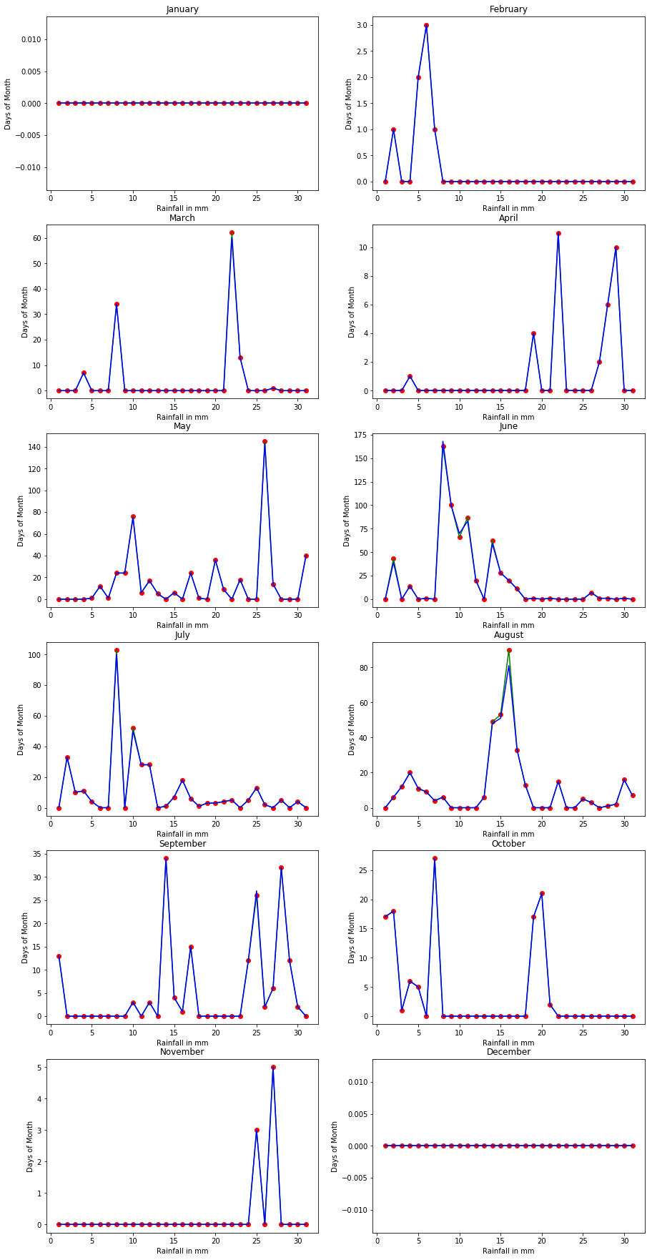

**Using Support Vector Regression**

**Predicted values**

| **Index** | **Actual Rainfall** | **Predicted Rainfall** |
| --- | --- | --- |
| **1892** | 1 | 1.099172 |
| **1895** | 2 | 2.098371 |
| **1896** | 3 | 3.097573 |
| **1897** | 1 | 1.099165 |
| **1925** | 7 | 7.094390 |
| **1929** | 34 | 34.072870 |
| **1943** | 62 | 62.050538 |
| **1944** | 13 | 13.089582 |
| **1948** | 1 | 1.099138 |
| **1956** | 1 | 1.099174 |
| **1971** | 4 | 4.096761 |
| **1974** | 11 | 11.091179 |
| **1979** | 2 | 2.098344 |
| **1980** | 6 | 6.095155 |
| **1981** | 10 | 10.091966 |
| **1988** | 1 | 1.099174 |
| **1989** | 12 | 12.090407 |
| **1990** | 1 | 1.099171 |
| **1991** | 24 | 24.080842 |
| **1992** | 24 | 24.080841 |
| **1993** | 76 | 76.039403 |
| **1994** | 6 | 6.095181 |
| **1995** | 17 | 17.086415 |
| **1996** | 5 | 5.095975 |
| **1998** | 6 | 6.095176 |

**Graph(SVR)**

Blue lines are predicted values, Green lines along with Red dots is the Actual value

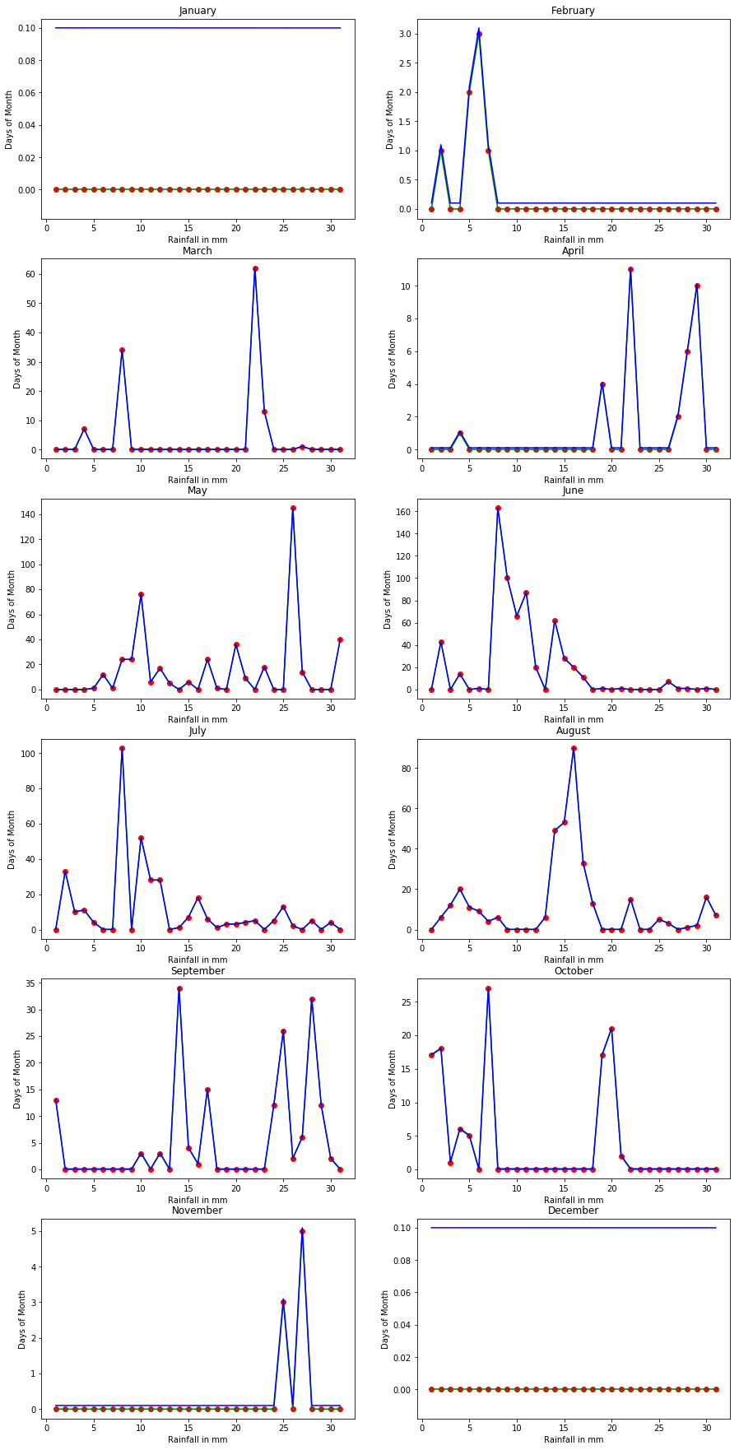

**Using K-nearest neighbors algorithm**

Predicted values

| **Index** | **Actual Rainfall** | **Predicted Rainfall** |
| --- | --- | --- |
| **1896** | 3 | 4 |
| **1925** | 7 | 10 |
| **1929** | 34 | 34 |
| **1943** | 62 | 59 |
| **1944** | 13 | 10 |
| **1971** | 4 | 3 |
| **1974** | 11 | 10 |
| **1979** | 2 | 1 |
| **1980** | 6 | 7 |
| **1981** | 10 | 10 |
| **1989** | 12 | 10 |
| **1991** | 24 | 21 |
| **1992** | 24 | 21 |
| **1993** | 76 | 75 |
| **1994** | 6 | 4 |
| **1995** | 17 | 16 |
| **1996** | 5 | 4 |
| **1998** | 6 | 8 |
| **2000** | 24 | 25 |
| **2003** | 36 | 36 |
| **2004** | 9 | 8 |
| **2006** | 18 | 18 |
| **2009** | 145 | 143 |
| **2010** | 14 | 16 |
| **2014** | 40 | 40 |

**Graph(K-nearest neighbors)**

Blue lines are predicted values, Green lines along with Red dots is the Actual value

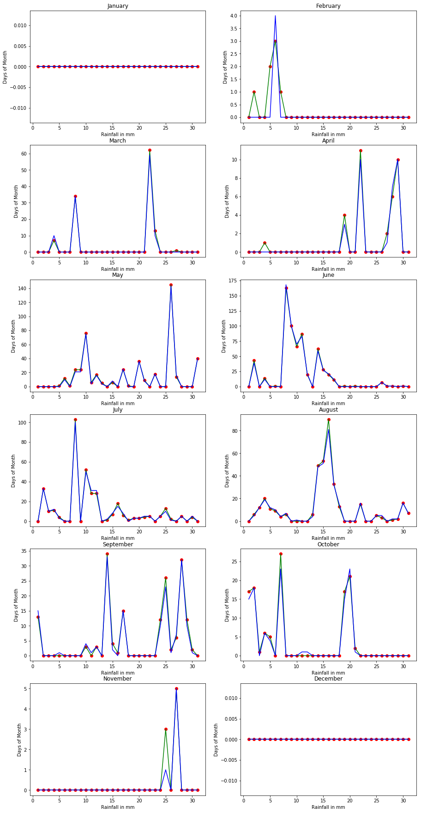

**Using Neural Network (MLPClassifier)**

Predicted values

| **Index** | **Actual Rainfall** | **Predicted Rainfall** |
| --- | --- | --- |
| **1929** | 34 | 21 |
| **1943** | 62 | 21 |
| **1991** | 24 | 18 |
| **1992** | 24 | 18 |
| **1993** | 76 | 21 |
| **2000** | 24 | 7 |
| **2003** | 36 | 21 |
| **2009** | 145 | 83 |
| **2014** | 40 | 21 |
| **2016** | 43 | 21 |
| **2022** | 163 | 168 |
| **2023** | 100 | 83 |
| **2024** | 66 | 21 |
| **2025** | 87 | 83 |
| **2026** | 20 | 7 |
| **2028** | 62 | 21 |
| **2029** | 28 | 7 |
| **2030** | 20 | 7 |
| **2047** | 33 | 21 |
| **2053** | 103 | 83 |
| **2055** | 52 | 21 |
| **2056** | 28 | 7 |
| **2057** | 28 | 7 |
| **2061** | 18 | 7 |
| **2080** | 20 | 7 |

**Graph (Neural Network)**

Blue lines are predicted values, Green lines along with Red dots is the Actual value

